Image | 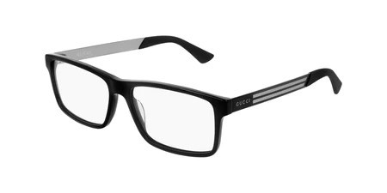
Brand | GUCCI
Model Name | GG 0692O
Price | RS 1499
PRODUCT DETAILS

